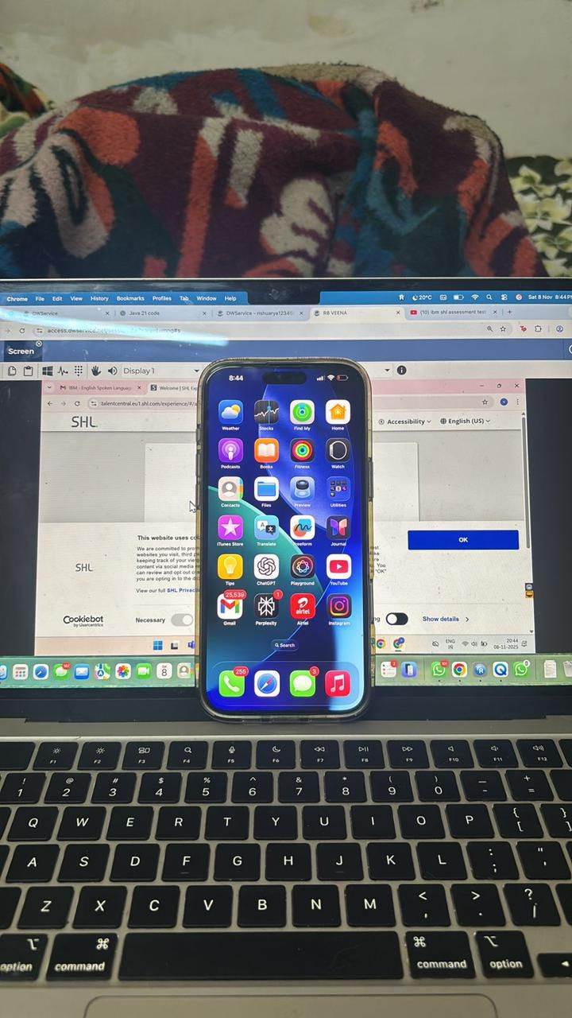
phone like this

Make sure your net will be good

Make phone in silent mode

Increase display time of phone so that it will not turn off the screen

Read ans smartly

Dont read ans like a book

All theory+codes I wil give

Prepare your introduction and project, i wil give project ans also based on your resume but better you also be prepared Thats it

Most imp:

Dont sit silent and wait for my ans, atleast do some Intraction with interviewer and say few words, meanwhile ans will come

Important concept:

1-Oops basic interview qus for Accenture

2- sql basic interview qus for Accenture

Search above thing in chatgpt and do study, however I wil send each and every ans, but I suggest be in good preparation for good result

4-1 AM SENDING QUS WHICH 20000% THEY WIL ASK TOMMOROW.

1-FIRST PASTE YOUR RESUME IN CHATGPT, AFTER THAT WRITE PROMPT:" I AM SENDING SITUAIONAL BASED QUS KINDLY GIVE ME ANS IN SIMPLE AND HUMAN WAY.

PREPARE THESE QUS AS A BACKUP PLAN, DONT WRRY I WIL SEND ANS AT INTERVIEW TIME, BUT FOR YOUR BENEFITS I SUGGEST BE PREPARED SO THAT YOU CAN ANS ALONE AND WITH CONFIDENCE V

5-1. Tell me about a time you had to meet a tight deadline. How did you handle it?

2. What would you do if you disagreed with your team lead's decision?

3. How would you handle a situation where you are assigned a task you don't know how to do?

4. Describe a situation where you faced a conflict with a teammate. How did you resolve it?

5. What would you do if you made a mistake that affected your team or project?

6. How would you deal with a team member who is not contributing equally?

7. Tell me about a time you received negative feedback. How did you respond?

8. How do you manage multiple tasks with different priorities at the same time?

9. What would you do if project requirements changed suddenly at the last moment?

10. How would you handle working with people from different backgrounds or cultures?

